Paratextual Information for Modern Ballroom Dancing Entry:

Juliet McMains

mcmains@uw.edu

[mcmains@u.washington.edu](https://mail.uvic.ca/owa/redir.aspx?C=FjCrBc5ogUGNjxRmjLJkjIQws40isdAIQp6TeWWpUdFAXmJ8HdUtzMKdhopmMrjTEKCeYCT0G10.&URL=mailto%3amcmains%40u.washington.edu)

Websites:

1) An American Ballroom Companion: <http://memory.loc.gov/ammem/dihtml/diessay7.html>

2) There are photos and videos of Alex Moore on this website: <http://watashinodancenote.com/concept.html>

Images:

1) There are great images of Irene and Vernon Castle from:

Castle, Vernon and Irene. 1914. *Modern Dancing*. New York: World Syndicate Company.

<http://memory.loc.gov/musdi/240/0039.jpg> (Castle Walk, from p. 46)

<http://memory.loc.gov/musdi/240/0036.jpg> (Castle Walk, from p. 42)

<http://memory.loc.gov/musdi/240/0030.jpg> (Tango, p. 36)

2) There are also great images of Maurice Mouvet in the book

Mouvet, Mourice. 1915. *Maurice’s Art of Dancing*. New York: G. Schirmer. I can see the whole book on google books, but I can’t download any pages and the pages with images are not numbered. But there are many great images in this book which might be in the public domain.

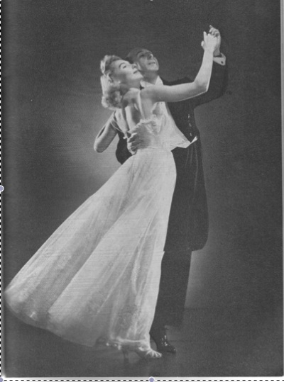3) It would be nice to have an image of Arthur Murray. I think the Arthur Murray International controls all images of him. There are many circulating in books, etc., but I think they would decide which one would be used in this context. I like this one, but they didn’t let me use it when I asked several years ago.

Videos:

1. Footage of Irene and Vernon Castle dancing in the film Whirl of Life in 1915. http://digital.nypl.org/lpa/nypl/about/about_d-d_ballroom.cfm
2. American Ballroom Companion Video Clip 75: Castle Walk Reconstructed by Elizabeth Aldrich. Performed by Cheryl Stafford and Thomas Baird, dancers; Boris Gurevich, piano. Music: "The Castle Walk" by James Reese Europe and and Ford T. Dabney, New York, Chicago, London, Australia: Jos. W. Stern and Co., 1914. <http://lcweb2.loc.gov/musdivid/075.mpg> (or other clips of ragtime dancing)
3. There is great footage of Alex Moore on this website: <http://watashinodancenote.com/concept.html>